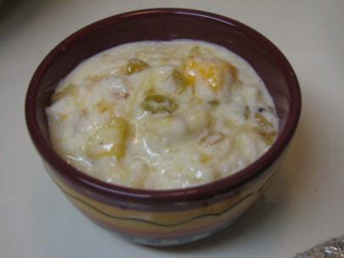

Cida Dahi

Preparation Time: 1 hour
Servings: 4
Ingredients:
- Chida [chipped rice] – 350 g
- Milk - 500 ml
- Cardamom powder - 2 tsp
- Sugar – 275 g
- Condensed milk - 6 tbsp
- Yoghurt - 500 ml
- Honey - 3 tbsp
- Mangoes, bananas, apple, litchi (Optional)

Instructions:
- Wash the chipped rice and drain.
- Soak the chipped rice in milk for an hour along with sugar and cardamom powder.
- Once it has come to room temperature, add condensed milk, yoghurt and honey.
- Mix well to combine.
- Chop the fruits and add them to the mixture.
- Offer to Krishna with love and devotion!

Bhakti Kids. (2021).

